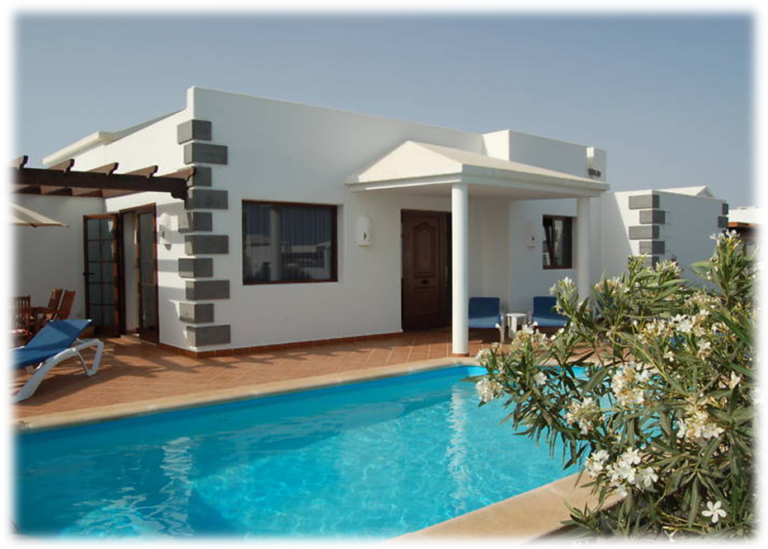

Thank you for choosing Casa Calma for your holiday!

Contents
Title | Page Number
Welcome | 2
Casa Calma  - Smoking | 3  3
- Swimming Pool | 4
- Doors and Windows | 4
- Security Alarm | 4
- Air Conditioning | 4
- Heating | 5
- Television/DVD/iPod | 5
- Books and Games | 6
- Outside Lights | 6
- Microwave | 6
- Hob Control | 6
- Oven | 6
- Dishwasher | 6
- Washing Machine | 6
- Iron/Ironing Board | 7
- Barbeque | 7
- Power | 7
- Picon | 7
- Refuse Collection | 7
- Taxi Service | 7
- Health Matters | 8
Playa Blanca | 9
About the Island  - Climate | 11  11
- Water | 11
- Mosquitoes | 11
- Supermarkets and Shops | 11
- Driving | 12
- Restaurants | 12
- Canarian Cuisine | 13
Local Map | 14
Day of Departure | 15
Useful Contact Numbers | 15

Welcome to Casa Calma!

We first visited Playa Blanca in 1997 and have been visiting the island ever since. During our holiday in 2004 we came across the Parque Del Rey development and decided there and then that a Villa on this development was for us.

We hope you have an extremely memorable stay and that you enjoy the distinct features of both Playa Blanca and Lanzarote as much as we do. All we ask is that you kindly treat the villa with respect as it is our home and very special to us.

The company who manage our villa ‘Montana Villas and Pools’ are located just five minutes down the road and their staff are extremely helpful and knowledgeable. Should you need any help or advice during your stay don’t hesitate to give them a call on: 0034 928 518 980.

The information that follows in this guide is designed to help make your stay enjoyable and to assist you in getting the best from the villa and Lanzarote.

We wish you a very pleasant holiday and hope you will return before too long.

Very best regards,

Gill and Trevor Crowder,

Jackie and Mike Wigglesworth

Casa Calma

Smoking

We respectfully ask that you do not smoke anywhere inside the villa. It is also requested that when smoking outside the villa, cigarette stubs are disposed of with consideration.

Swimming Pool
The pool is clearly a major advantage of staying at Casa Calma. In order to achieve maximum enjoyment of this feature, there are a few guidelines that you need to adhere to:
- Use of the pool is entirely at your own risk and children should be supervised at all times.
- The pool cover should be on the pool at all times when not in use. The cover not only protects from dirt and dust but also magnifies the sun’s energy throughout the day and its reflective underside maintains the heat in the water during the night. The cover typically raises the water temperature by up to 6ºC.
- The cover should be removed from the pool by slowly rotating the roller clockwise whilst ensuring that the cover winds squarely on to the roller. Please try to ensure the cover does not rub on the edge of the pool when winding as this can fray the edges.
- The cover should be installed on the pool by pulling the drawstring slowly from the centre of the pool.
- Please do not let children cover or uncover the pool.
- Please do not sit or attempt to stand on the cover roller.
- Please do not use any glasses in or around the pool. Plastic glasses are provided for use on the pool terrace.
- The floor tiles in the villa are very slippery when stepped on with wet feet or when the floor has been left wet by others – take care to dry off properly when going from the pool in to the villa. You should also avoid running around the edge of the pool as this to can be slippery when wet.
- The pool is serviced twice every week by our own team at Montana Villas and Pools. This includes cleaning and maintenance of the correct chemical balance. Please do not throw anything other than pool toys into the water.
- If you are unsure about any aspects of the pool or pool safety please ask the fully qualified pool cleaners when they visit or call into Montana Villas and Pools to ask their advice.

Doors and Windows
When leaving the villa please keep the entrance key in the key safe at all times to avoid being locked out.

Lanzarote can often be quite windy and for this reason, please be careful that the windows and external doors do not slam which could cause injury and/or damage.

Security Alarm

To arm the system
Leave the villa and once outside press the button with the lock symbol – you will hear a single beep and the system is armed. If no beep is heard then pull out the aerial and try again.

To disarm the system
Before opening the door press the button with the unlock symbol – you will hear two beeps and the system is disarmed. Again, if no beep is heard pull out the aerial and try again.

The third button is a panic button and once pressed will set the alarm siren off and contact the key holder. The alarm System is via a telephone to a key holder and if activated will contact them immediately.

If activated by accident then to silence the alarm press the unlock button.

Air Conditioning
The air conditioning units fitted to the lounge and master bedroom are top quality class AA units. To operate please follow these instructions and we ask that you treat the remote control with care as they are very expensive to replace.

- There must be credit in the meter adjacent to the front door before the units will operate. The meter will accept either one or two euro coins.
- The meter measures electricity consumption and not time therefore using low settings or just one unit will mean your Euros last longer.
- Any credit left at the end of your stay will be available for the next guest. It is not possible to give refunds.
- The remote control is complex supporting many adjustments of the units. It is however strongly recommended that just the fan and temperature setting are adjusted to suit your needs. This makes the operation of the units extremely simple. To operate the units:

  - Press the yellow on off button, a green light will appear on the unit and the blades will open.
  - Adjust the temperature up and down using the arrow on the right of the remote control.
  - Adjust the fan by pressing the fan icon on the left of the remote control to the desired level. Note: for night mode i.e. quiet mode set the fan to show the tree and moon symbol.
  - When switching from unit to unit it may be necessary to press the on off button twice, this aligns the remote to this unit.
  - To close down simply press the on off button once more.

Heat Mode
Using the mode button select the sun icon and set the desired temperature and fan speed as in air con mode. To return to air con select the snow flake symbol using the mode button.

Television
To turn on the television screen press the red button at the top of the black remote control.
- Using the black remote control press the ‘source’ button.
- By using the arrows scroll to ‘scart’ and press ok.
- Using the silver remote control turn on the satellite box (red button at the top right hand corner).
- Press ‘ok’ to access the channel guide by using the arrows to scroll.
- To change the volume, use the black remote control.

DVD Player
- To activate the DVD player press ‘DVD’ at the top of the black remote control.
- Insert disks into the right hand side of the screen (shiny side facing you).
- Volume, play, pause, stop etc are all located on the black remote control.
- To eject, press the triangle on the top left of the television.
- Use the arrows and ‘ok’ button to navigate through menus.

iPod Streaming
- To activate iPod streaming, press ‘IPOD’ at the top of the black remote control.
- Connect the iPod to the designated slot located on the television stand.
- Wait for the iPod to load.
- Use the arrows to navigate through the I-pod menus.
- Press ‘i-Pod menu’ to return to the previous menu.

Books and Games
A selection of books and games are available for the use of guests. The games can be found in the bottom drawer of the first set of drawers to the right of the kitchen. The books can be found in the unit located in the wardrobe in the master bedroom.

Outside Lights
Please ensure you switch outside lights off during the daytime and at any time when they are not needed.

Microwave
A microwave is provided for your use, you should find the controls self explanatory.

Hob Control
- Touch the control on the extreme right of the panel; this will bring up 4 illuminated signs. (It isn’t necessary to press).
- Use the central control to select the required ring – touch to move clockwise.
- When selected ring is flashing, use the + or – signs to increase/decrease the heat (maximum, 9)
- To alter the heat, touch the middle control again, then + or – to reach the desired temperature.
- Switch off by either touching the extreme right control or by decreasing the temperature to 0. H (hot) will follow.

Oven
- To use the oven or grill, turn the left hand knob to the hand symbol (manual).
- Use the middle knob to select oven or grill.
- Use the right hand knob to select temperature.

Dish Washer
- When loaded, press the button on the far left (the temperature will be flashing)
- Close the door & the programme should start.
- When finished, the machine will bleep.
- Open door & press far-left button to turn off.

Washing Machine
- Turn the temperature control to 30-40 (a hot wash takes a very long time).
- Turn programme control to sinteticos.
- Press the far-left start button.
- At the completion of the wash, turn the programme control to stop.

Iron/Ironing Board
There is an Iron and Ironing board provided for your use. The iron is normally located in a kitchen cupboard, with the board usually found in one of the wardrobes.

Barbecue
There is a barbeque provided at the villa for your use. You may find there is some charcoal left from previous guests but if not you will find it available from the local convenience store and most of the supermarkets in town. We have found that you can purchase prepacked bags of charcoal where you place the whole bag in the barbeque and light it. These are very quick and convenient to use. Please note the barbeque cleaning is not part of the normal villa cleaning and we ask guests to please clean after use ready for the next guests.

Power
The electricity supply in Lanzarote is occasionally susceptible to interruption but not usually for any prolonged periods. In the case of a loss of power, there is a torch supplied in one of the kitchen drawers. In the event that a device has tripped out the power (this can happen when a bulb blows) then just reset on the fuse box behind the front door. The voltage in Lanzarote is the same as the UK, so any appliances brought with you will work with the aid of a plug adapter.

Picon
The black gravel-like substance that covers the garden area is crushed volcanic rock and is called picon. It has a quality that keeps the sun’s rays from drying the earth beneath and it collects and transfers the dew that occurs at night in to the earth. It also gets stuck in the soles of trainer shoes and then scratches the tiles of the villa floor so please do not walk on it and then transfer it in to the villa.

Refuse Collection
Please leave your rubbish in the communal bins behind the white doors near the entrance of the development. We encourage people to take their waste to the bins as foodstuffs etc can begin to smell quite quickly due to the warm temperatures, also bins attract creepy crawlies.

Taxi Service
Taxis are available from Playa Blanca centre to the villa and cost around €3.

Health Matters
There is a very good English-speaking doctor in Playa Flamingo next door to the car rental shop. The telephone number is: 928 519 039. There are numerous chemists around Lanzarote, the nearest being in Playa Blanca 928 518 942. There are many more medicines available ‘over the counter’ in Spain than in the UK, for example strong painkillers and antibiotics. The pharmacists usually speak English and are generally very helpful.

As most of Europe is now part of the European Community, if you or any of your dependants are suddenly taken ill or have an accident during a visit to any of these countries, free or reduced-cost emergency treatment is available – in most cases on production of a valid Form E111. Only state-provided emergency treatment is covered, and you will receive treatment on the same terms as nationals of the country you are visiting. Private treatment is generally not covered, and state-provided treatment may not cover all of the things that you would expect to receive free of charge from the NHS. You may also wish to contact your holiday insurance company for advice should you encounter a problem.

Playa Blanca
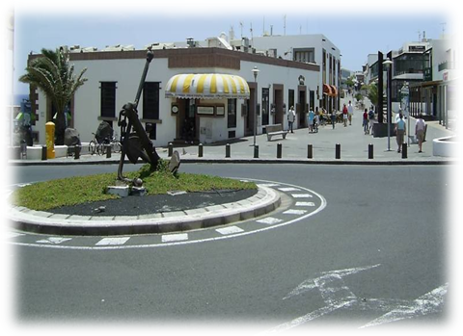
Playa Blanca is our favourite part of Lanzarote, that's why we bought a villa here!
It is a clean, quiet haven located on the Southern most point of Lanzarote. From every beach you can see the islands of Fuerteventura and Los Lobos, one of the most spectacular beach views available in the World. There are four separate golden beaches in Playa Blanca and at least a further eight beaches collectively known as Playas de Papagayo. These are located on the East side of Playa Blanca near the new 5 star Marina complex and are widely known as the finest collection of beaches in the whole of Spain.
Playa Blanca was for centuries a quiet fishing village with only the odd Pirate invasion to keep the locals on their toes! Although the village is now more built up and reliant on tourism it still retains a Pirate free fishing fleet which you can see leaving the local harbour each Morning.
Playa Blanca has numerous exciting and very reasonably priced restaurants and bars. You can eat well in Playa Blanca, very well! Spanish, Italian, Mexican, English and Chinese are all available here. Most restaurants have great views out to sea and across the Bocaina straits to Los Lobos and Fuerteventura. All are excellently decorated and well stocked for wine and drinks.
For lunch why not go native and enjoy "Tapas" at one of the local Sea front restaurants?
So, there are fantastic bars, restaurants and beaches. There is also a great selection of shops in the village centre selling everything from designer clothes to Sombreros! Oh, and if you get bored of shopping there is a beach just off the main shopping street!
What else?
Car, bike and quad hire, tourist excursions, submarine trips, diving lessons and fishing gear can all be arranged in Playa Blanca!
Or you could always relax by the pool! From the harbour at Playa Blanca there are ferries that cross several times a day to Fuerteventura. It is possible to go to the island as a foot passenger or with a car and the 45-minute crossing is good fun in itself as you can sit on the open-air terrace and enjoy the ocean.

One of the most beautiful beaches on the island is in very close proximity to Playa Blanca. Papagayo beach is a must-see place for anyone staying in Playa Blanca, consisting of several small coves and accessible via a dirt track after paying the admittance fee of €3 per car.

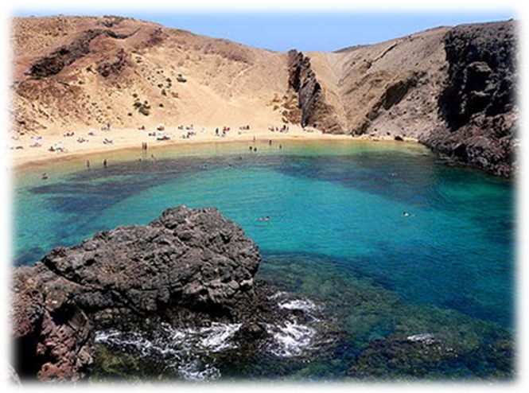

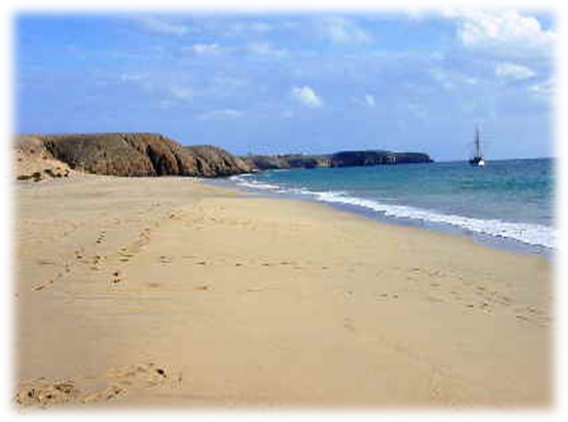
About the Island

Climate
Lanzarote usually enjoys a near perfect climate, not getting too hot in the summer, or too cool in the winter. You should beware of the power of the sun’s rays, which can be masked by the breeze that is often present on the island. Please make sure you use adequate protection to get the best enjoyment from your holiday.

Water
Water is the island’s most precious commodity. Please use it sparingly. The tap water in Lanzarote does not carry any germs but since all water is reclaimed from the sea by the very expensive process of desalination, it has a very high mineral content and can cause stomach upsets as you will not be used to it. Whilst tap water is fine for cleaning teeth etc., you are advised to drink only bottled water. Bottled water is available from all supermarkets and the various brands are quite widely varying in price. Our experience shows very little in taste between the brands so there is little point in buying the most expensive brands. The water in the square bottles such as Agua De La Palma or Sierra Cazokla is far easier to manage in the fridge. We tend to use Chafariz which is available for around €1 for a 5-litre bottle.

Mosquitoes
At certain times of the year mosquitoes are present on Lanzarote and the main problem is that you usually don’t notice them until you are bitten. Mosquito bites can be very uncomfortable. We recommend the use of a plug-in repellent.

Supermarkets and Shops
The Canary Islands are a shopping paradise because there is no customs barrier for traders. Not even the tax-free shops at the airports can compete with prices in the Canaries. Liqueurs, tobacco, cameras, video recorders, watches, you will find most are cheaper than in their countries of origin.

There are several perfumeries in Playa Blanca, Puerto del Carmen and Arrecife all offering excellent bargains – these shops are much cheaper than the airport duty free shops.

- The closest supermarket is a local one, leave the villa turning right at the gate. Turn left at the main road, keep walking, go past the school on your left and take the next right turn. You will see “SUPERMERLOBY”, a small convenience store on your left hand side. It closes between 2pm and 5pm.
- The next shops are about 1km away in the centre of Playa Blanca. Leave the villa turning right at the gate, and then right at the main road. You will reach a T-junction where you should turn left. Cross the road and see a small area of undeveloped land and a footpath worn into the ground. This footpath takes you straight to the Port from here you can reach many shops, bars and restaurants.
- The best supermarkets are in the centre of Playa Blanca. There are a few to choose from, all of which have a good selection of products at reasonable prices. These include Spar, Netto and Hyper Dino – Hyper Dino tending to have the greatest variety of produce.
- Maceys located in Tias stock a wide range of high quality British products. They also stock health foods and gluten free, diabetic and organic products http://www.maceyslanzarote.com/

Driving
- Make sure you drive on the right-hand side of the road.
- Driving is easy in Lanzarote however, watch out for other hire cars, especially on Thursdays because other holiday maker’s will have just arrived and won’t be used to driving on the right.
- Speed limits are clearly indicated as are no ‘overtaking zones’. The police impose heavy fines for breaking the motoring laws, which you will be expected to pay on the spot in cash.
- There are several petrol stations available on the island but only a few of them open 24 hours, so don’t let your tank get too low. You will normally find the station to be manned so just ask the attendant to put in the amount required. We normally purchase in 10 euro lots as petrol goes a long way in Lanzarote.
- Don’t park in any parking bay that is marked in yellow – this denotes that the bay is reserved. Other than that you will find nearly all parking is free in Playa Blanca so it is just a matter of finding a suitable space.

Restaurants
There are many good restaurants in Playa Blanca and the surrounding areas, here are some of our favourites:
- La Romantica – sea views – location near the taxi rank. Chateaubriand is a must!
- La Bocaina – on the right just past the filling station on the way to the town centre. Far more impressive than it looks from the outside.
- Las Aromas – down the street almost opposite the bus station. A little more pricey but great food.
- El Horno De La Abuela – a traditional Spanish restaurant away from the busy sea front offering great quality food. Situated on La Tegala close to the taxi rank.
- La Era - Yaiza, behind the Town Hall. Tel. 928 83 00 16. Open all week from 1.00pm till 11.00pm. Booking advised. http://www.la-era.com. This restaurant in the lovely little village of Yaiza, is set in a 300-year-old farmhouse with gardens, courtyards and outbuildings lovingly restored by Cesar Manrique into a fascinating and beautiful place to eat and drink. La Era serves authentic Canarian cuisine as well as International dishes.

Canarian Cuisine
Typical Canarian Cuisine includes many dishes prepared with fish caught in large amounts along the coast. Fish is served with the famous papas arrugadas, potatoes boiled in salt water, and a hot sauce called mojo.

Traditional dishes are watercress stew, the popular sancocho canario, made with salted fish and mojo, rabbit in salmorejo, a sauce consisting of water, vinegar, olive oil, salt and pepper, sweet black pudding, etc. Banana and tomato, the main source of wealth of the islands, also occupy an important place in Canary cooking as do avocado pear and papaya fruit as well as gofio, a roasted mixture of wheat, maize or barley, which is eaten with certain dishes of the country instead of bread. Among the sweets, especially outstanding are tirijalas, bienmesabes, frangollo, bizcochos lustrados, turrones de melaza or gofio and pastry. Among the drinks produced in the islands, there is especially rum, rum-cum-honey, malmsey wine and the local wines produced on Lanzarote.

Local Map
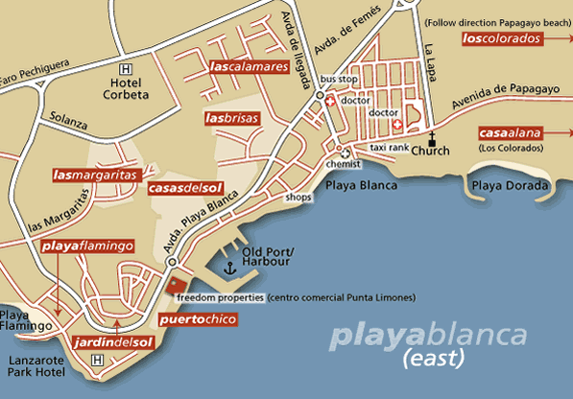

Casa Calma, 43 Parque Del Rey.

Day of Departure

On your day of departure you are required to vacate the villa by 10am so that the housekeepers can prepare the villa for the next guest’s arrival. When you do depart, please secure the villa and take all personal belongings.

Thank you.

Useful Contact Numbers

For all problems with the villa or pool and any queries during your stay then please contact Montana Villas Office – 928 518 980 – office hours 10-6pm Monday to Thursday. 10-4 Fri/Sat. Mobile – 646 022 695 - Please avoid out of hours calls, if possible.

A representative from the management team will normally visit you within the first 48 hours of arrival to ensure you have no problems. If you miss them please feel free to call into their offices. On leaving the development turn left and then turn right at the first roundabout, Montana are located at the end of this road on the left hand side.

Emergency Services: 112

Arrecife Hospital – 900 595 000

Medical Centre (Playa Blanca) – 928 83-01-90
Chemist (Playa Blanca, C/ El Correillo, 87) – 928 518 942
Taxi (Playa Blanca) - 928 524 222

Montana Villa and Pools - 928 518 980

Police - 928 830 107

